Design and Implementation of a Secure Phone-as-Car-Key Platform for Car Rental Services

Shane Power - 20102592

Contents
Introduction 3
Functional Summary 4
Assumptions 5
Functional Requirements 6
System Context 6
Detailed Requirements 6
1. Car Key App 6
2. Vehicle Access Control Unit (VACU) 7
3. CANoe and Vehicle Network 8
4. Cloud Backend and Manager App 8
Data Requirements 9
System Design Diagrams 11
Functional Decompositions 11
Car Key App 11
Vehicle Access Control Unit 11
CANoe 12
Cloud Backend and Manager App 12
Sequence Diagrams 13
Successful Unlock/Lock 13
Unlock Failed (Key Invalid) 13
Manager Revoking Key 14
Sample App Designs 15
Car Key App 15
Manager App 15
Cybersecurity Goals 16
Threat Model 16
Proof Of Concept Prototype 18

Introduction
This project aims to design and implement a secure smartphone-based digital car key system, with a focus on car rental and car fleet management. The aim of the system is to replace traditional physical keys with securely provisioned digital keys. This will improve user convenience and reduce the administrative overhead and the security risks associated with handling physical keys. This is inspired by the shift in the car industry towards keyless vehicle access, and the growth of contactless, app-based car rental services.
The proposed prototype consists of a mobile Car Key App, a Vehicle Access Control Unit (VACU) running on a PC with Python, a cloud based management platform with an application for fleet managers, and a CAN interface using Vector CANoe. The Car Key App authenticates the user using biometric or PIN verification and initiates a secure unlock request. This request is transmitted via Bluetooth Low Energy (BLE) to the VACU, which performs access validation and cybersecurity checks like a vehicle lock ECU.
When the VACU receives a lock/unlock request, it validates it by checking its encryption key against stored keys in the cloud database and uses cybersecurity techniques such as checking the timestamp and cryptographic nonce. When access is approved, the VACU forwards the request to CANoe through a COM interface, which generates and transmits a real Controller Area Network (CAN) message to a Jaguar Land Rover vehicle testing rig. This message is used to wake the rig and simulate vehicle access behaviour, such as door lock and unlock events, showing interaction with real vehicle equipment.
The cloud backend provides fleet management functionality through a Manager App. This includes secure user authentication, digital key provisioning and revocation, temporary guest access management, and event logging. Fleet managers can remotely assign vehicles, monitor access activity, and revoke digital keys, allowing them to manage their fleet through a single app.
A comprehensive threat model will be developed to analyse potential cybersecurity risks in the system, such as replay attacks, relay attacks, and device compromise. These threats will be evaluated through controlled testing, and techniques to protect against these demonstrated such as authentication, nonces, timestamps, and secure communication channels between the system components. This will evaluate the security, practicality, and realism of a digital car key system from a cybersecurity point of view.
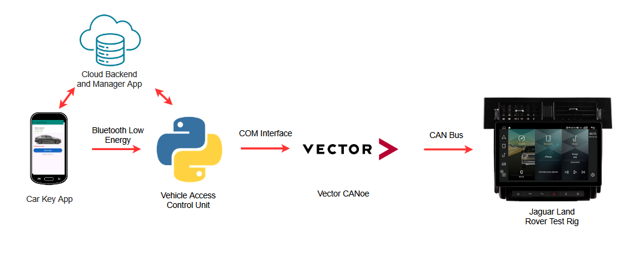

Functional Summary
This project will develop a secure smartphone based digital car key system, aimed at improving user experience and fleet management for car rental services. The system replaces physical keys with a digital authentication and unlock process through a mobile app, which provides improved security and convenience for customers and fleet companies.
The Car Key App is the user’s interface for authentication and vehicle access. Users unlock the app using biometrics(Face ID, fingerprint) or PIN and can then initiate an unlock or lock request. The app validates the user’s session and encryption key against data from the cloud backend.
Once the request is validated, the app sends an unlock command to the Vehicle Access Control Unit (VACU) running on a PC, via Bluetooth Low Energy (BLE). The VACU processes the unlock request and enforces defined cybersecurity and authorisation rules, such as cryptographic key pair checking, digital certificates, timestamp and nonce checking, similar to a real vehicle ECU. Rather than directly controlling the vehicle hardware, the VACU acts as the secure control point between the mobile app and the vehicle test environment.
Upon authorisation, the VACU forwards the request to CANoe, which is responsible for generating and transmitting a real Controller Area Network (CAN) message to the Jaguar Land Rover testing rig. This CAN message is used to wake the rig and trigger simulated vehicle access behaviour, such as door lock or unlock events.
The cloud backend manages user authentication, digital key provisioning, and event logging. Through the Manager App, fleet operators can create, assign, and revoke digital keys, manage temporary guest access, and monitor vehicle access activity. The cloud service supports scalable fleet operation and implements key revocation in the case of a lost or stolen device, as well as real-time updates of any access requests.
Overall, the system integrates mobile biometric authentication, Bluetooth Low Energy communication, CAN based vehicle communication, and cloud based fleet management to demonstrate a secure, contactless car key solution for modern rental and fleet use cases.

Assumptions
- The smartphone used for testing supports Bluetooth Low Energy (BLE) and can hold a stable BLE connection with the Vehicle Access Control Unit (VACU).
- The Jaguar Land Rover (JLR) testing rig is available and operational, allowing CANoe to transmit real Controller Area Network (CAN) messages to wake the rig and trigger simulated vehicle functions such as door lock and unlock behaviour.
- The cloud backend is available and provides reliable services for user authentication, digital key provisioning, and event logging throughout the testing period.
- The Car Key App and the Manager App need to have access to a stable internet connection to communicate with the cloud backend.
- The user’s device should be able to implement secure key storage through the Android Keystore or an equivalent built-in security system.
- All digital certificates and cryptographic key pairs required for authentication and secure communication can be generated securely and stored appropriately
- The Vehicle Access Control Unit (VACU) is running on a system that supports BLE communication and has enough processing power to process and send unlock requests in a reasonable timeframe
- Cloud service latency remains within acceptable limits to support near real time event logging and fleet management updates.
- The prototype will be evaluated within a controlled hardware and network environment, and doesn’t account for large-scale deployment or any hostile network conditions beyond those considered in the threat model.

Functional Requirements

System Context

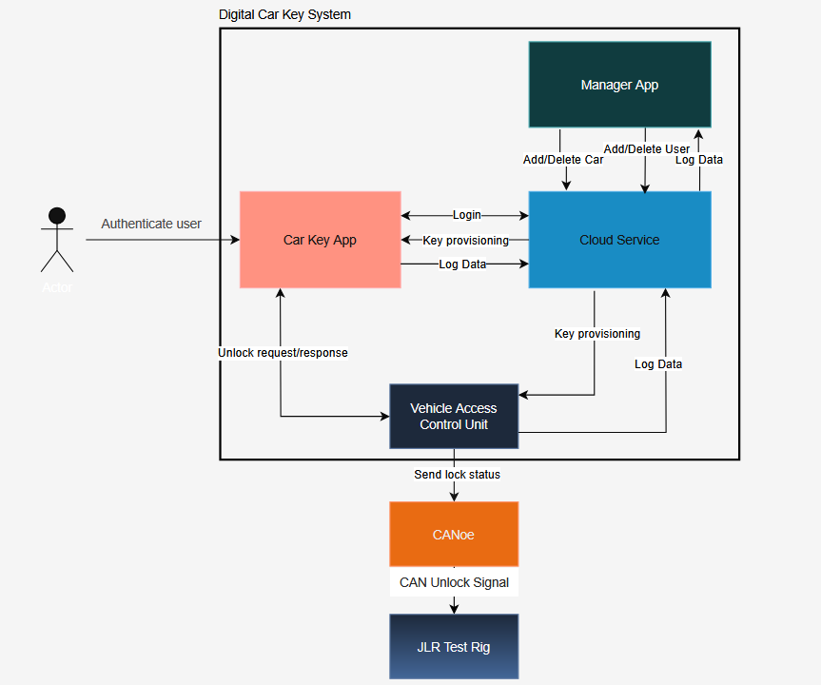

Detailed Requirements

Car Key App

  - User Authentication
    - The mobile app must allow users to authenticate using biometrics (fingerprint, Face ID) or a secure PIN.
    - Only authenticated users can access key management or vehicle unlock functions.
    - Authentication tokens must be stored securely within the phone’s keystore.

  - Key Provisioning and Management
    - The app must synchronise with the cloud backend to validate key status, permissions, and user roles before issuing unlock commands.
    - The app must handle temporary guest keys with time-limited access or restricted permissions.
    - The app must reject commands if the key is revoked or expired.

  - Secure Communication and Unlock Process
    - The app must communicate with the BLE–CANoe interface via Bluetooth Low Energy (BLE).
    - Unlock commands must be bound to an authenticated user session and a valid KeyID.
    - The app must provide clear feedback to the user for command success, failure, or connection errors.

  - Data Handling
    - Private keys for each digital key must be stored in the phone keystore.
    - KeyID attributes include: KeyID, VehicleID, UserID, Expiry Date/Time, Permissions, Key status (active or revoked).
    - Unlock events generated by the app must be logged to the cloud with timestamp, user ID, vehicle ID, and action.

Vehicle Access Control Unit (VACU)

  - Communication Role
    - The VACU must establish and maintain BLE connections with authorised mobile
devices.
    - The VACU must receive unlock and lock commands from the Car Key App in a
reliable and timely manner.
    - The VACU must handle BLE disconnections and reconnections properly without system failure.
2.2 Access Control and Cybersecurity
2.2.1. The VACU must validate any incoming commands against the defined security and authorisation rules before forwarding the command to CANoe.
2.2.2. Commands must be rejected if the required validation checks fail.
2.2.3. The VACU must act as the only access point between the mobile application and the vehicle network.
2.3 Integration with CANoe
2.3.1. Upon successful validation, the VACU must forward authorised commands to CANoe.
2.3.2. The VACU must not directly generate or transmit CAN messages onto the vehicle network.
2.3.3. Communication between the VACU and CANoe must be reliable and have minimal latency.

CANoe and Vehicle Network

  - CAN Message Generation
3.1.1 CANoe must generate valid CAN messages corresponding to actions on the test rig such as ignition status, door lock status.
3.1.2 CAN messages must conform to the expected format of the JLR testing rig.
3.1.3 CANoe must transmit messages reliably onto the CAN bus.
3.2 Test Rig Interaction
3.2.1 CANoe must be capable of waking the Jaguar Land Rover testing rig using CAN signals.
3.2.2 Simulated vehicle behaviour, such as door lock and unlock events, must be triggered by the CAN messages.
3.3.3 Monitoring of CAN messages sent and received to the test rig should be possible through CANoe.

Cloud Backend and Manager App

  - User and Key Management
4.1.1 The cloud backend must manage all user authentication and role-based access control.
4.1.2 Fleet managers must be able to create, assign and revoke digital keys through the Manager App.
4.1.3 Changes to key status must be synchronised across the system in quick time.
4.2 Event Logging and Requirements
4.2.1 All unlock and lock attempts must be logged, including successful and failed actions.
4.2.2 Log entries must include timestamp, user ID, vehicle ID, action performed, and the result.
4.2.3 Fleet managers must be able to view access logs through the Manager App.
4.3 Security and Data Protection
4.3.1 Communication between components in the system and the cloud backend must use encrypted channels.
4.3.2 Sensitive data stored in the cloud must be protected using encryption and access controls.
4.3.3 Key revocation should be possible, in the case of a stolen or lost phone, or compromise of the vehicle.

Data Requirements

- User Data
  - Each user will have a unique User ID which will be managed by cloud authentication.
  - User profiles will include basic details such as name, email, and the assigned role (driver, manager)
  - Authentication data such as passwords or biometrics will be securely stored and encrypted by secure cloud storage and the keystore on device.

- Digital Key Data
  - Each key will be represented by a KeyID which will be linked to a specific vehicle and user.
  - The private key associated with each digital key will be stored on the phone keystore only.
  - Attributes for KeyID include:
    - KeyID
    - VehicleID
    - UserID
    - Expiry Date and Time
    - Permissions
    - Public key associated with Vehicle Access Control Unit (VACU)
    - Key status (active or revoked)

- Vehicle Data
  - Each vehicle entry in the database will have:
    - VehicleID
    - Vehicle Type / Model
    - Associated Vehicle Access Control Unit
    - Current Status
    - Assigned User

- Unlock Event Log
  - Every unlock attempt will be logged to the cloud
  - Each log entry includes
    - LogID
    - Timestamp
    - UserID
    - VehicleID
    - Action ( Unlock or Lock)
    - Result (Success or Failure)
    - Nonce

- Vehicle Access Control Unit Data
  - The VACU will store:
    - Unique VACU Identifier
    - Public keys of valid users
    - Latest valid nonces and timestamps for replay attack prevention
    - Log data

- CAN Bus data
  - CAN bus will send CAN messages to JLR rig to request unlock/lock

- Data Security
  - All data transmitted between system components must be encrypted using secure communication protocols.
  - Secure cloud storage will handle secured storage of user, vehicle and event data
  - Keys and credentials will be stored using phone keystore and secure cloud storage.

System Design Diagrams

Functional Decompositions

Car Key App
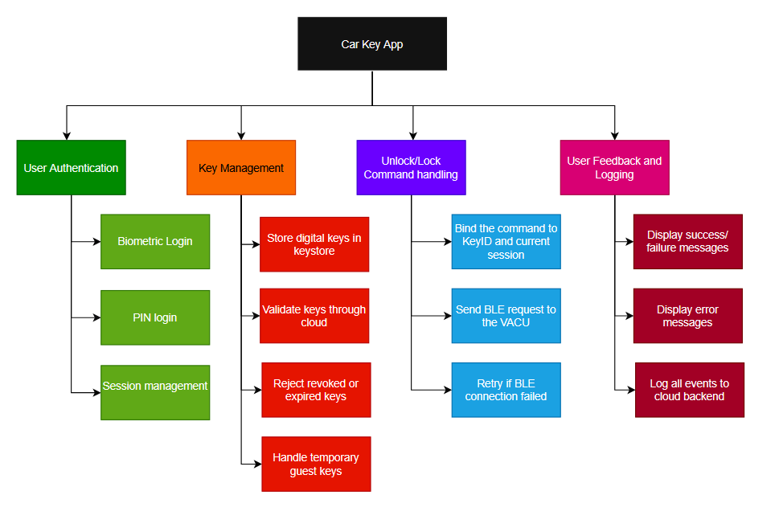

Vehicle Access Control Unit
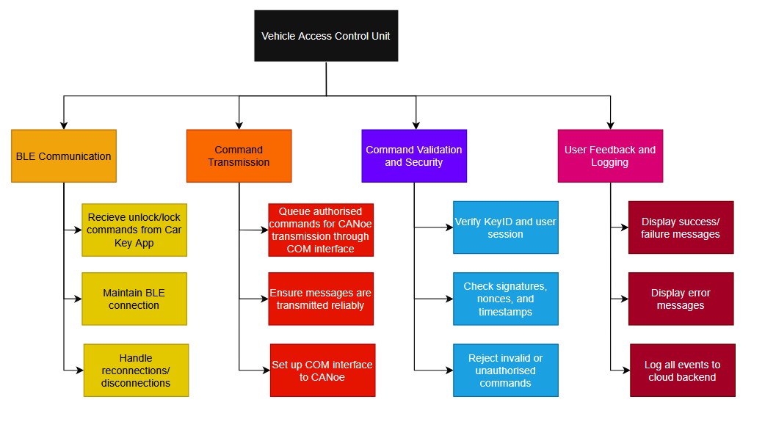

CANoe
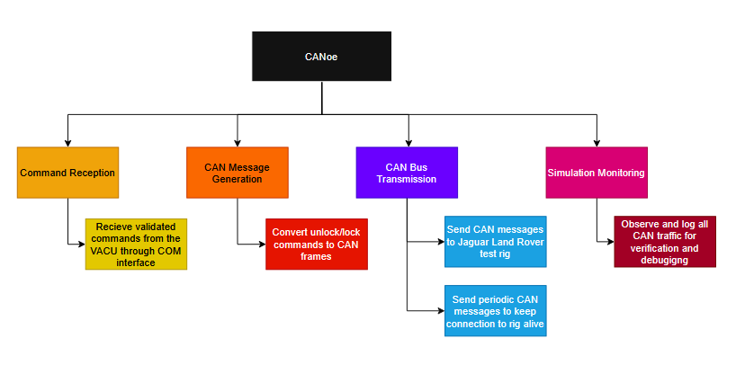

Cloud Backend and Manager App
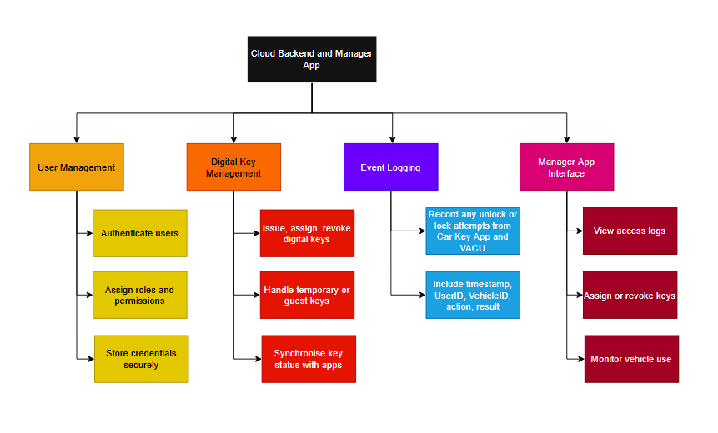

Sequence Diagrams

Successful Unlock/Lock
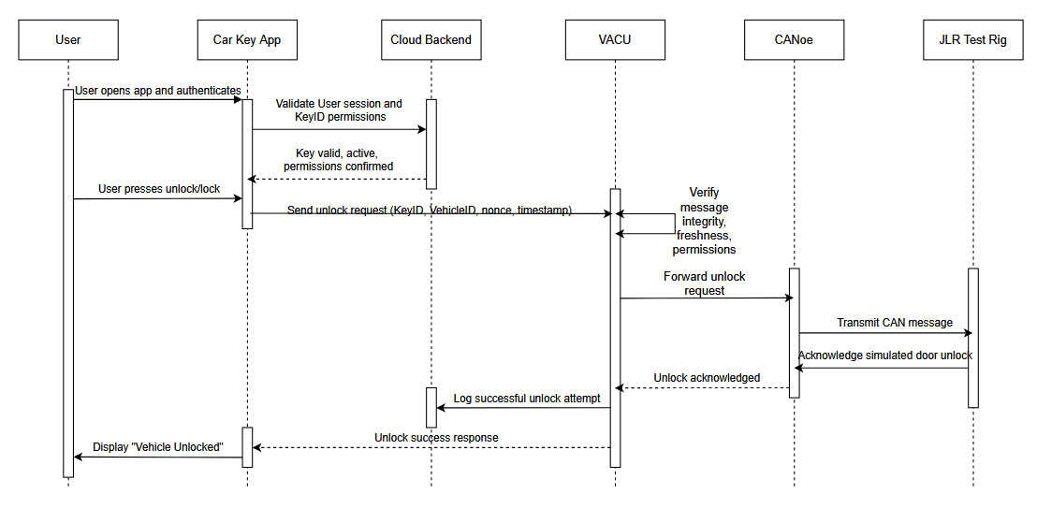

Unlock Failed (Key Invalid)
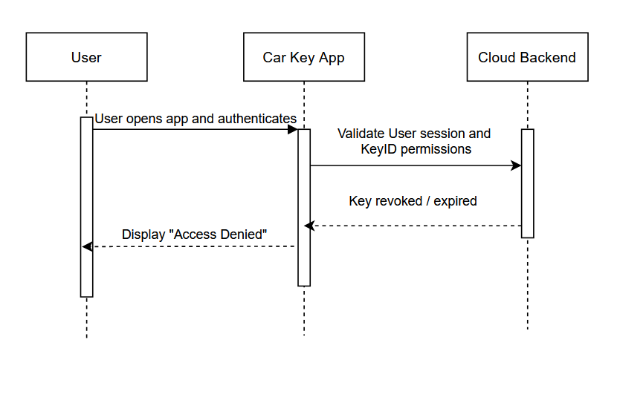

Manager Revoking Key

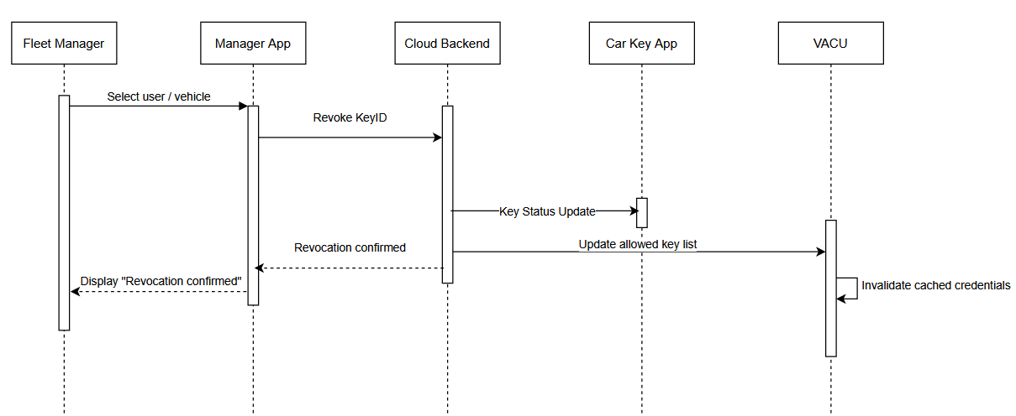

Sample App Designs

Car Key App
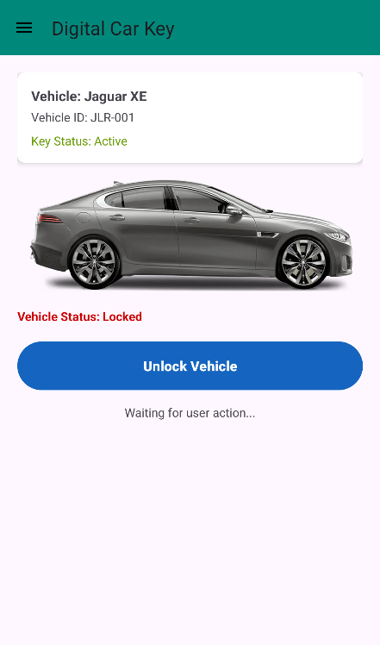
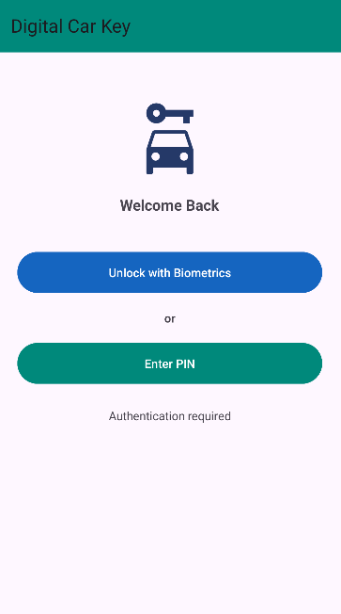
Main Screen
Login Page

Manager App
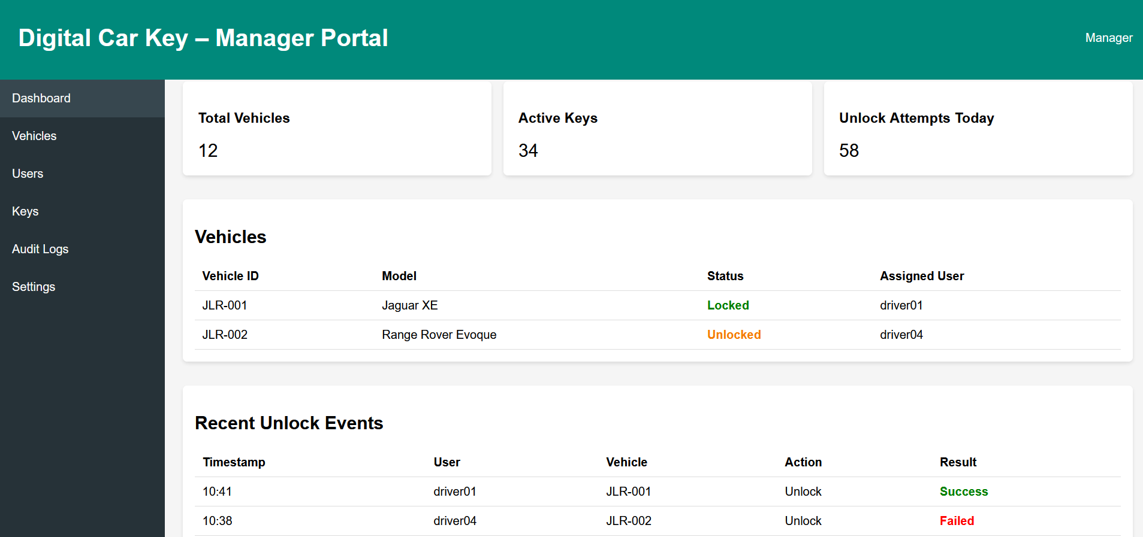

Cybersecurity Goals

- Secure Authentication
  - Ensure that only authorised users can unlock vehicles.
  - Authentication should be implemented through biometrics or secure PIN.
  - In the case of a phone being stolen or lost, unauthorised use should be prevented through key revocation.
- Data Confidentiality
  - All sensitive information (nonces, KeyIds, cryptographic keys) should be protected while in transit and at rest.
  - Any Bluetooth Low Energy communication should be protected by ensuring BLE Secure Connections are used, by implementing pairing and bonding.
  - Communications between the Car Key App, VACU and the Cloud Backend should be protected with TLS.
- Data Integrity
  - It should be ensured all unlock requests are unaltered and genuine.
  - Replay attacks should be prevented by implementing challenge response techniques, such as nonces, signatures, and timestamps.
  - The VACU should validate every request before sending any signals to the vehicle network.
- Data Availability
  - In the case of a network failure, the system should handle the failure gracefully and return to a safe resting state.
  - To avoid brute-forcing attacks, a time lockout should be implemented between each unlock attempt.
- Accountability
  - There should be a secure and complete log of all unlock or lock events.
  - The logs should include the timestamp, UserID, VehicleID, the action, the result, and nonce.

Threat Model

Potential Threat Sources:
- External Attacker: An attacker trying to access a vehicle without a valid key
- Insider Threat: A manager with privileges, abusing their authority
- Man In the Middle: An attacker intercepting Bluetooth or cloud communication
- Replay Attacker: An attacker who captures a successful unlock command and replays it to trigger an unlock.
- Compromised Device: A connected phone or PC that has been tampered with

Potential Attack Types:
- Unauthorised Access from External Attacker
In this attack, the attacker has obtained a KeyID or valid credentials from a phone or the cloud. This would allow the attacker to unlock a vehicle.
To mitigate this:
- Biometric and PIN authentication implemented
- Keys are stored securely in the phone’s keystore
- Key revocation ensures compromised keys are deactivated

- Replay Attack
In this attack, the attacker captures a valid unlock message sent through BLE from a user’s phone to the VACU. The attacker can then transmit this unlock message to the VACU again to trigger a successful unlock.
To mitigate this:
- Nonces are implemented for each unlock request. A nonce is short for “number once” and is a randomly generated number that is used only once in a communication. The nonce includes a timestamp which guarantees the message is only valid for a specific period.
- A challenge-response protocol is implemented, where the VACU will send a challenge to the phone app consisting of the nonce, timestamp and its identifier. The phone app will sign this challenge with the private key stored in the phone’s keystore and send it back to the VACU. The VACU will check the nonce and timestamp to ensure the unlock request wasn’t sent before.

- Man In the Middle Attack
In this attack, an attacker intercepts the BLE transmission between the phone and the VACU and can pretend to be the phone to the VACU, or pretend to be the VACU to the phone. The attacker can then try to replay old unlock requests or inject their own unlock requests into the transmission. To mitigate this:
- Nonce and timestamp implementation prevent replay attacks
- Only the phone itself has the private key in its keystore to sign the challenge response. If an attacker tries to change the message, the VACU will refuse to verify the signature.
- BLE Secure Connection will be implemented, which use pairing and bonding to encrypt communication from device to device.

- Cloud Data Breach
In this attack, the cloud backend is compromised. Private user data could be access, and access to key provisioning options could be accessed by an attacker, allowing unauthorised devices to be allocated keys. To mitigate this:
- Private keys are stored on user’s phones, so an attacker still needs to gain access to a user’s phone to issue unlock requests.
- TLS Encryption is implemented
The mitigation of these threats will be demonstrated and each attack vector will be tested in a controlled environment, to show the system’s resilience against cybersecurity attack.

Proof Of Concept Prototype

A prototype of this system has been in development since September. Originally, a Raspberry Pi was used to act as the secure vehicle ECU. It functioned as the BLE server and also communicated with the test rig using a PiCAN 2 Can Bus board integrated into the Pi. A simple test application was created using Android Studio, which implemented simple BLE pairing functionality and sent a simple unlock message over BLE. This was installed onto a real Android phone.
The Raspberry Pi was set up in the Automotive Lab in SETU, and the CAN bus was connected to a JLR test rig. The Android phone paired with the Raspberry Pi and sent an unlock request to the Pi. Once the Pi received this request, it sent out a CAN message which changed the ignition state of the test rig. This test was a success and the rig would wake up from the CAN message. However, the BLE implementation proved to be temperamental on the Raspberry Pi. Unlock requests would only be picked up half of the time, and the devices had to constantly be repaired. This was not solid enough for a proper demonstration, so the prototype was adjusted to use the VACU, a Python application which implemented BLE and encryption methods. Vector CANoe is used to communicate on the CAN bus. The two programs communicate over the Microsoft COM protocol, which is built-in to CANoe. When an unlock request is verified, the VACU python script sends the unlock over COM to CANoe, which then sends the appropriate CAN message over the CAN bus to the test rig.

